Predicting sentiment from product reviews

Summary / Observations:
Tasks:
- Used product review data from Amazon.com to predict whether the sentiments about a product (from its reviews) are positive or negative. Built a song recommend-er model and explored the song data and the recommendations made by our model.
- Trained a logistic regression model.
- Explore various evaluation metrics: accuracy, confusion matrix, precision, recall.
- Explore how various metrics can be combined to produce a cost of making an error.
- Explore precision and recall curves
- Explore various different values of thresholds, compute the precision and recall scores, and then plot the precision-recall curve.
Observations:
- The precision increase with a higher threshold
- The recall decreases with a higher threshold
- Among all the threshold values tried, identified the smallest threshold value that achieves a precision of 96.5% or better
- Using threshold = 0.98, identified how many false negatives do we get on the test data
- Trained Logistic regression classifier using stochastic gradient ascent.
Tasks:
- Extracted features from Amazon product reviews.
- Implemented stochastic gradient ascent with L2 penalty
- Compared convergence of stochastic gradient ascent with that of batch gradient ascent
- Explored the effects of step sizes on stochastic gradient ascent
Observations:
- When we set the batch size as the length of the feature matrix in training data, as each iteration passes, the average log likelihood in the batch increases

Amazon Sentiment Review Analysis:
In each of the following models, the following parameters are used for tuning using cross-
validation and the final accuracy is calculated.
1) Decision Tree Classification:
The decision tree implementation in Assignment 1 obtained its best accuracy, after pruning
the decision tree with a maximum depth of 10 on the Amazon Review dataset.
The training accuracy obtained is: 88.5% and Testing Accuracy obtained is: 83.9%
2) Neural Network Classification:
The Neural Network implementation in Assignment 2 obtained a best accuracy by setting
the following parameters: iterations = 500, number of hidden layers = 600, Activation
function = RELU, Solver = SGD, Learning Rate = 0.001, Regularization Parameter alpha-
0.0001.
The above settings gave a training accuracy of 91.81% and Testing accuracy of 73.89%
3) K-Nearest Neighbors Classification Model:
For K-Nearest Neighbor classification model, after hyperparameter tuning of K, the value of
K =6 gives more accuracy on the Testing dataset. Hence, K = 6 is considered as the tuned
parameter. Hence it obtained an accuracy of 86.62% on the Training dataset, 85.31% on the
testing dataset. (Reference Assignment 3)
4) Adaboosting Classification model:
After tuning the parameters of the n_estimators, the value n_estimator=900 gives a better
accuracy which reduces the error on both the training as well as a testing dataset.
The above settings gave an accuracy of 94.63% on the training dataset, 74.66% on the
testing dataset.
5) SVM Classification Model:
For the Support Vector Machine Classification model, the values gamma, C are tuned and
comparison of various kernels is done. After tuning, the Poly Kernel seems to be the best fit
and the degree used is 3.
The above parameters on the SVM Classification model gave an accuracy of 85.54% on the
Training dataset, 85.53% on the testing dataset.
6) Naïve Bayes Classification Model:
For the Naïve Bayes classification model, the priors are not needed to train the learning
model. The Laplacian smoothing of 1.0 is applied to the Training dataset to estimate the
value. The Multinomial NB gave a better training accuracy of 87.6% and a testing accuracy
of 82.79%.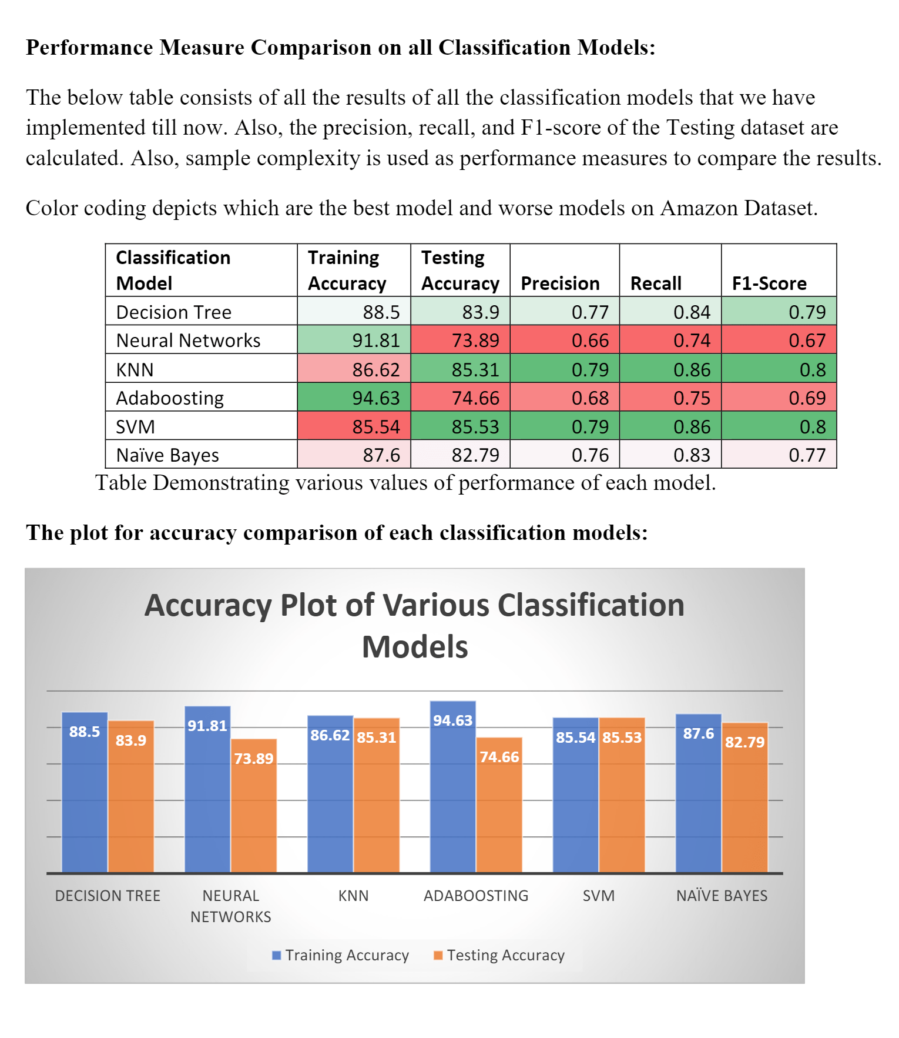
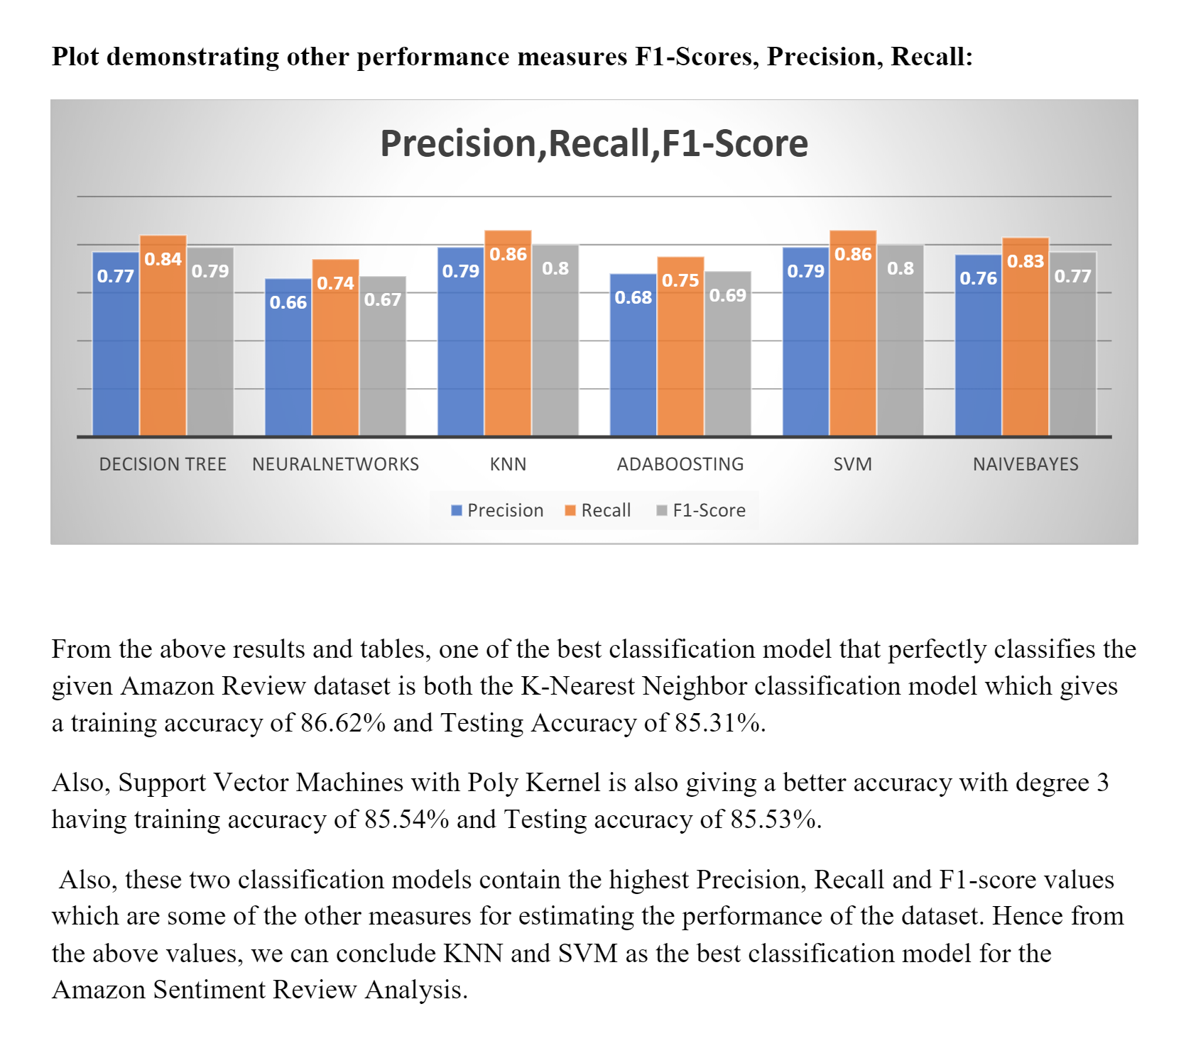
From the above results and tables, one of the best classification model that perfectly classifies the
given Amazon Review dataset is both the K-Nearest Neighbor classification model which gives
a training accuracy of 86.62% and Testing Accuracy of 85.31%.
Also, Support Vector Machines with Poly Kernel is also giving a better accuracy with degree 3
having training accuracy of 85.54% and Testing accuracy of 85.53%.
Also, these two classification models contain the highest Precision, Recall and F1-score values
which are some of the other measures for estimating the performance of the dataset. Hence from
the above values, we can conclude KNN and SVM as the best classification model for the
Amazon Sentiment Review Analysis.

Assignment2:

Analysing Product Sentiment [Based on product reviews]:
Code:
sentiment_model = graphlab.logistic_classifier.create(train_data,
target='sentiment',
features=['word_count'],
validation_set=test_data)
sentiment_model.evaluate(test_data, metric='roc_curve')
giraffe_reviews['predicted_sentiment'] = sentiment_model.predict(giraffe_reviews, output_type='probability')
giraffe_reviews = giraffe_reviews.sort('predicted_sentiment', ascending=False)
giraffe_reviews[0]['review']
giraffe_reviews[-1]['review'] => Last table element

- That function Evaluate allows you to evaluate its quality on some test data. And we're gonna provide a particular metric and this metric is called the roc_curve.
- But the roc_curve is a way to explore the false positives and false negatives in that confusion matrix that we discussed.
- Explored the most positive & negative aspects of a product
- Execute sentiment analysis code with the IPython notebook
- Load and transform real, text data
- Using the .apply() function to create new columns (features) for our model
- Compare results of two models, one using all words and the other using a subset of the words as below:
selected_words = ['awesome', 'great', 'fantastic', 'amazing', 'love', 'horrible', 'bad', 'terrible', 'awful', 'wow', 'hate']
- Compare learned models with majority class prediction
- Examine the predictions of a sentiment model
- Build a sentiment analysis model using a classifier
Data: Amazon Baby

PART2-CLASSIFICATION

ASSIGNMENT1:

Predicting sentiment from product reviews:
The goal of this assignment is to explore logistic regression and feature engineering with existing GraphLab Create functions.
In this assignment, you will use product review data from Amazon.com to predict whether the sentiments about a product (from its reviews) are positive or negative. You will:
- Use SFrames to do some feature engineering
- Train a logistic regression model to predict the sentiment of product reviews.
- Inspect the weights (coefficients) of a trained logistic regression model.
- Make a prediction (both class and probability) of sentiment for a new product review.
- Given the logistic regression weights, predictors and ground truth labels, write a function to compute the accuracy of the model.
- Inspect the coefficients of the logistic regression model and interpret their meanings.
- Compare multiple logistic regression models.
Logistic Regression Code:
sentiment_model = graphlab.logistic_classifier.create(train_data,
target = 'sentiment',
features=['word_count'],
validation_set=None)
weights = sentiment_model.coefficients
scores = sentiment_model.predict(sample_test_data, output_type='margin')

Probability predictions¶
Recall from the lectures that we can also calculate the probability predictions from the scores using:
P(yi=+1|xi,w)=11+exp(−wTh(xi)).
sentiment_model.predict(sample_test_data, output_type='probability')

Compute accuracy of the classifier¶
We will now evaluate the accuracy of the trained classifier. Recall that the accuracy is given by
accuracy=# correctly classified examples/# total examples

Learn another classifier with fewer words
significant_words = ['love', 'great', 'easy', 'old', 'little', 'perfect', 'loves',
'well', 'able', 'car', 'broke', 'less', 'even', 'waste', 'disappointed',
'work', 'product', 'money', 'would', 'return']
train_data['word_count_subset'] = train_data['word_count'].dict_trim_by_keys(significant_words, exclude=False)
test_data['word_count_subset'] = test_data['word_count'].dict_trim_by_keys(significant_words, exclude=False)

Train a logistic regression model on a subset of data

simple_model = graphlab.logistic_classifier.create(train_data,
target = 'sentiment',
features=['word_count_subset'],
validation_set=None)
simple_model

Compared both the models: [ Sentiment Model and Simple Model]
- Computed the accuracy for both the above models with Training set as well as Test set.

ASSIGNMENT2:

Implementing logistic regression from scratch
The goal of this assignment is to implement your own logistic regression classifier. You will:
- Extract features from Amazon product reviews.
- Convert an SFrame into a NumPy array.
- Implement the link function for logistic regression.
- Write a function to compute the derivative of the log likelihood function with respect to a single coefficient.
- Implement gradient ascent.
- Given a set of coefficients, predict sentiments.
- Compute classification accuracy for the logistic regression model.

Code:
We compiled a list of 193 most frequent words into a JSON file.
Now, we will load these words from this JSON file:

import json
with open('important_words.json', 'r') as f: # Reads the list of most frequent words
important_words = json.load(f)
important_words = [str(s) for s in important_words]
Apply text cleaning on the review data
def remove_punctuation(text):
import string
return text.translate(None, string.punctuation)
products['review_clean'] = products['review'].apply(remove_punctuation)
Compute word counts (only for important_word
for word in important_words:
products[word] = products['review_clean'].apply(lambda s : s.split().count(word))

ASSIGNMENT 3:

Logistic Regression with L2 regularization
The goal of this assignment is to implement your own logistic regression classifier with L2 regularization. You will do the following:
- Extract features from Amazon product reviews.
- Convert a data frame into a NumPy array.
- Write a function to compute the derivative of log likelihood function with an L2 penalty with respect to a single coefficient.
- Implement gradient ascent with an L2 penalty.
- Empirically explore how the L2 penalty can ameliorate overfitting.

Steps and Write up:
- Load Data
- Clean up Data
- Remove punctuation using Python's built-in string functionality.
- Compute word counts (only for the important words), Split out the words into individual columns
- Train-Validation split - We split the data into a train-validation split with 80% of the data in the training set and 20% of the data in the validation set. We use seed=2 so that everyone gets the same result.
However, the portion of data that we don't train on will be used to help select model parameters. Thus, this portion of data should be called a validation set.
Recall that examining performance of various potential models (i.e. models with different parameters) should be on a validation set, while evaluation of selected model should always be on a test set.
Code:
train_data, validation_data = products.random_split(.8, seed=2)
- Convert SFrame to NumPy array - Two arrays are returned: one representing features and another representing class labels.
Note: The feature matrix includes an additional column 'intercept' filled with 1's to take account of the intercept term.
- Convert both the training and validation sets into NumPy arrays using above function.
- To Predict Probability write a function- predict_probability - Building on logistic regression with no L2 penalty assignment [define a function]
- Recall from lecture that the link function for logistic regression can be defined as:
P(yi=+1|xi,w)=11+exp(−wTh(xi)),
where the feature vector h(xi) is given by the word counts of important_words in the review xi.
- Adding L2 penalty - Extending logistic regression with L2 regularization [ To Prevent Overfitting]
  - L2 regularization is particularly useful in preventing overfitting
  - that for logistic regression without an L2 penalty, the derivative of the log likelihood function is:
- ∂ℓ∂wj=∑i=1Nhj(xi)(1[yi=+1]−P(yi=+1|xi,w))
  - Adding L2 penalty to the derivative- It takes only a small modification to add a L2 penalty. All terms indicated in red refer to terms that were added due to an L2 penalty.
  - Recall from the lecture that the link function is still the sigmoid:
P(yi=+1|xi,w)=11+exp(−wTh(xi)),
  - We add the L2 penalty term to the per-coefficient derivative of log likelihood:
∂ℓ∂wj=∑i=1Nhj(xi)(1[yi=+1]−P(yi=+1|xi,w))−2λwj
  - The per-coefficient derivative for logistic regression with an L2 penalty is as follows:
∂ℓ∂wj=∑i=1Nhj(xi)(1[yi=+1]−P(yi=+1|xi,w))−2λwj and for the intercept term, we have
∂ℓ∂w0=∑i=1Nh0(xi)(1[yi=+1]−P(yi=+1|xi,w))
Note: As we did in the Regression course, we do not apply the L2 penalty on the intercept. A large intercept does not necessarily indicate overfitting because the intercept is not associated with any particular feature.
  - Write a function- feature_derivative_with_L2 to compute 2λwj that computes the derivative of log likelihood with respect to a single coefficient wj. Unlike its counterpart in the last assignment, the function accepts five arguments:
    - errors vector containing (1[yi=+1]−P(yi=+1|xi,w)) for all i
    - feature vector containing hj(xi) for all i
    - coefficient containing the current value of coefficient wj.
    - l2_penalty representing the L2 penalty constant λ
    - feature_is_constant telling whether the j-th feature is constant or not.
- Compute Log Likely hood -Write a function - compute_log_likelihood_with_L2 - To verify the correctness of the gradient ascent algorithm, we provide a function for computing log likelihood (which we recall from the last assignment was a topic detailed in an advanced optional video, and used here for its numerical stability).
  - ℓℓ(w)=∑i=1N((1[yi=+1]−1)wTh(xi)−ln(1+exp(−wTh(xi))))−λ∥w∥22
- Write Logistic Regression Function, logistic_regression_with_L2: Pseudo Code as below:
  - Get the Initial Coefficients
  - For itr in Max_iter
    - Predict Probability using predict_probability
    - Compute indicator value for (y_i = +1)
    - Compute the errors as indicator – predictions
    - For Loop # loop over each coefficient
      - is_intercept = (j == 0)
      - Compute the derivative for coefficients[j], using feature_derivative_with_L2 [with errors computed above as one of the inputs]
derivative = feature_derivative_with_L2(errors, feature_matrix[:,j], coefficients[j], l2_penalty, is_intercept)
      - Add the step size times the derivative to the current coefficient
coefficients[j] += step_size * derivative
      - Checking whether log likelihood is increasing using compute_log_likelihood_with_L2
lp = compute_log_likelihood_with_L2(feature_matrix, sentiment, coefficients, l2_penalty)
Now that we have written up all the pieces needed for regularized logistic regression, let's explore the benefits of using L2 regularization in analyzing sentiment for product reviews. As iterations pass, the log likelihood should increase.
As below, we train models with increasing amounts of regularization, starting with no L2 penalty, which is equivalent to our previous logistic regression implementation.
# run with L2 = 0,4,10,1e2,1e3,1e5
coefficients_0_penalty = logistic_regression_with_L2(feature_matrix_train, sentiment_train,
initial_coefficients=np.zeros(194),
step_size=5e-6, l2_penalty=0, max_iter=501)
Findings:
Compare Coefficients:
Helper Function to create a table to Compare Coefficients:
table = graphlab.SFrame({'word': ['(intercept)'] + important_words})
def add_coefficients_to_table(coefficients, column_name):
table[column_name] = coefficients
return table
run the function add_coefficients_to_table for each of the L2 penalty strengths.
add_coefficients_to_table(coefficients_0_penalty, 'coefficients [L2=0]')
Plot the coefficient path for words not listed in either positive_words or negative_words?

ASSIGNMENT 9:

Exploring precision and recall
The goal of this assignment is to understand precision-recall in the context of classifiers.
- Use Amazon review data in its entirety.
- Train a logistic regression model.
- Explore various evaluation metrics: accuracy, confusion matrix, precision, recall.
- Explore how various metrics can be combined to produce a cost of making an error.
- Explore precision and recall curves.
Pseudo Code / Write-up:
- Load Amazon data set
- Extract word counts and sentiments¶
  - Remove punctuation.
  - Remove reviews with "neutral" sentiment (rating 3).
  - Set reviews with rating 4 or more to be positive and those with 2 or less to be negative.
- Train -Test Split
- Train a logistic regression classifier
model = graphlab.logistic_classifier.create(train_data, target='sentiment',
features=['word_count'],
validation_set=None)
- Evaluate the model
  - Measure Accuracy
accuracy=# correctly classified data points/# total data points
Code:
accuracy= model.evaluate(test_data, metric='accuracy')['accuracy']
- Baseline: Majority class prediction
We used the majority class classifier as a baseline (i.e. reference) model for a point of comparison with a more sophisticated classifier. The majority classifier model predicts the majority class for all data points.
Typically, a good model should beat the majority class classifier. Since the majority class in this dataset is the positive class (i.e., there are more positive than negative reviews), the accuracy of the majority class classifier can be computed as follows:

baseline = len(test_data[test_data['sentiment'] == 1])/len(test_data)
print "Baseline accuracy (majority class classifier): %s" % baseline

Findings:
our logistic regression model better than the baseline (majority class classifier)
- Evaluate using Confusion Matrix metric
  - The accuracy, while convenient, does not tell the whole story. For a fuller picture, we turn to the confusion matrix. In the case of binary classification, the confusion matrix is a 2-by-2 matrix laying out correct and incorrect predictions made in each label as follows:
Code:
confusion_matrix = model.evaluate(test_data,metric='confusion_matrix')['confusion_matrix']
- Compute False Positives - Calculated as follows:
false_positive = confusion_matrix['count'][(confusion_matrix['target_label'] == -1) & (confusion_matrix['predicted_label'] == +1)]
- Compute the cost of mistakes.
  - You want to monitor your product's reviews in order to respond to complaints. Even a few negative reviews may generate a lot of bad publicity about the product. So you don't want to miss any reviews with negative sentiments --- you'd rather put up with false alarms about potentially negative reviews instead of missing negative reviews entirely. In other words, false positives cost more than false negatives. (It may be the other way around for other scenarios, but let's stick with the manufacturer's scenario for now.)
  - Suppose you know the costs involved in each kind of mistake:
    - $100 for each false positive.
    - $1 for each false negative.
    - Correctly classified reviews incur no cost.
false_positive_test = confusion_matrix[(confusion_matrix['target_label'] == -1) & (confusion_matrix['predicted_label'] == +1)]['count'][0]
false_negative_test = confusion_matrix[(confusion_matrix['target_label'] == +1) & (confusion_matrix['predicted_label'] == -1)]['count'][0]

print "False Positives: ", false_positive_test
print "False Negatives: ", false_negative_test
cost_test = (100 * false_positive_test) + (1 * false_negative_test)

- Precision and Recall - Precision
You may not have exact dollar amounts for each kind of mistake. Instead, you may simply prefer to reduce the percentage of false positives to be less than, say, 3.5% of all positive predictions. This is where precision comes in:
[precision]=[# positive data points with positive predicitions]/[# all data points with positive predictions]
=
[# true positives]/[# true positives]+[# false positives]
Code:
precision = model.evaluate(test_data, metric='precision')['precision']

- Calculate False Positives Fraction as below:
total_reviews=confusion_matrix['count'].sum()
false_positives_frac=false_positive_test/float(total_reviews)
print "Answer-False Positives Fraction: ", false_positives_frac

- Precision and Recall - Recall
A complementary metric is recall, which measures the ratio between the number of true positives and that of (ground-truth) positive reviews:
[recall]=[# positive data points with positive predicitions][# all positive data points]=[# true positives][# true positives]+[# false negatives]
Code:
recall = model.evaluate(test_data, metric='recall')['recall']

• Calculate Fraction of the positive reviews correctly predicted as positive by the classifier as below:
true_positive_test = confusion_matrix[(confusion_matrix['target_label'] == +1) & (confusion_matrix['predicted_label'] == +1)]['count'][0]
true_positive_test_frac=true_positive_test/float(total_reviews)

print "Answer-fraction of the positive reviews in the test_set were correctly predicted as positive: ", true_positive_test_frac

- Precision – Recall TradeOff
We first examine what happens when we use a different threshold value for making class predictions. We then explore a range of threshold values and plot the associated precision-recall curve.

- Vary the Threshold
False positives are costly in our example, so we may want to be more conservative about making positive predictions. To achieve this, instead of thresholding class probabilities at 0.5, we can choose a higher threshold.
    - Write a function called apply_threshold that accepts two things
probabilities (an SArray of probability values)
threshold (a float between 0 and 1).
The function should return an SArray, where each element is set to +1 or -1 depending whether the corresponding probability exceeds threshold.
    - Run prediction with output_type='probability' to get the list of probability values. Then use thresholds set at 0.5 (default) and 0.9 to make predictions from these probability values.

Code:
probabilities = model.predict(test_data, output_type='probability')
predictions_with_default_threshold = apply_threshold(probabilities, 0.5)
predictions_with_high_threshold = apply_threshold(probabilities, 0.9)
Findings:
The number of positive predicted reviews decreases as the threshold increased from 0.5 to 0.9
- Exploring the associated precision and recall as the threshold varies
  - By changing the probability threshold, it is possible to influence precision and recall. We can explore this as follows:
Code:
# Threshold = 0.5
precision_with_default_threshold = graphlab.evaluation.precision(test_data['sentiment'],
predictions_with_default_threshold)

recall_with_default_threshold = graphlab.evaluation.recall(test_data['sentiment'],
predictions_with_default_threshold)

# Threshold = 0.9
precision_with_high_threshold = graphlab.evaluation.precision(test_data['sentiment'],
predictions_with_high_threshold)
recall_with_high_threshold = graphlab.evaluation.recall(test_data['sentiment'],
predictions_with_high_threshold)

Findings:
Default Threshold
Precision (threshold = 0.5): 0.948706099815 Recall (threshold = 0.5) : 0.949955508098

High Threshold
Precision (threshold = 0.9): 0.969527896996 Recall (threshold = 0.9) : 0.884463427656

    - the precision increase with a higher threshold
    - the recall decreases with a higher threshold
- Precision-recall curve
  - we will explore various different values of tresholds, compute the precision and recall scores, and then plot the precision-recall curve.
  - Among all the threshold values tried, identified the smallest threshold value that achieves a precision of 96.5% or better
  - Using threshold = 0.98, identified how many false negatives do we get on the test_data
Code:
threshold = 0.98
predictions = apply_threshold(probabilities, threshold)
confusion_matrix = graphlab.evaluation.confusion_matrix(test_data['sentiment'], predictions)
confusion_matrix
- Evaluate specific search Terms
So far, we looked at the number of false positives for the entire test set. In this section, let's select reviews using a specific search term and optimize the precision on these reviews only. After all, a manufacturer would be interested in tuning the false positive rate just for their products (the reviews they want to read) rather than that of the entire set of products on Amazon.
  - Precision-Recall on all baby related items
Code:
baby_reviews = test_data[test_data['name'].apply(lambda x: 'baby' in x.lower())]
probabilities = model.predict(baby_reviews, output_type='probability')

Findings:
  - Of all the threshold values tried, what is the smallest threshold value that achieves a precision of 96.5% or better for the reviews of data in baby_reviews - 0.86363636363636365
  - The threshold value larger than the threshold used for the entire dataset to achieve the same specified precision of 96.5%

ASSIGNMENT10:
Training Logistic Regression via Stochastic Gradient Ascent
The goal of this assignment is to implement a logistic regression classifier using stochastic gradient ascent. You will:
- Extract features from Amazon product reviews.
- Convert an SFrame into a NumPy array.
- Write a function to compute the derivative of log likelihood function (with L2 penalty) with respect to a single coefficient.
- Implement stochastic gradient ascent with L2 penalty
- Compare convergence of stochastic gradient ascent with that of batch gradient ascent

Pseudo-Code / Write-up:
- Load Data from Amazon product reviews
- Process reviews data set
  - Remove punctuation using Python's built-in string manipulation functionality.
  - Compute word counts (only for the important_words)
- Split data into training and validation sets
- Convert SFrame to NumPy array
- Like previous assignments, Two arrays are returned: one representing features and another representing class labels.
- we convert both the training and validation sets into NumPy arrays.
- Building on logistic regression
  - Let us now build on Module 3 assignment. Recall from lecture that the link function for logistic regression can be defined as:
- P(yi=+1|xi,w)=11+exp(−wTh(xi)),
  - where the feature vector h(xi) is given by the word counts of important_words in the review xi.
  - Write a function, predict_probability that produces probablistic estimate for P(y_i = +1 | x_i, w).estimate ranges between 0 and 1.
predict_probability(feature_matrix, coefficients):
- Derivative of log likelihood with respect to a single coefficient
  - Let us now work on making minor changes to how the derivative computation is performed for logistic regression.
  - the derivative of log likelihood with respect to a single coefficient is as follows:
∂ℓ∂wj=∑i=1Nhj(xi)(1[yi=+1]−P(yi=+1|xi,w))
  - In Module 3 assignment, we wrote a function to compute the derivative of log likelihood with respect to a single coefficient wj. The function accepts the following two parameters:
errors vector containing (1[yi=+1]−P(yi=+1|xi,w)) for all i
feature vector containing hj(xi) for all i
Code: feature_derivative(errors, feature)
  - To verify the correctness of the gradient computation, we provide a function for computing average log likelihood
  - To track the performance of stochastic gradient ascent, we provide a function for computing average log likelihood.
ℓℓA(w)=1N∑i=1N((1[yi=+1]−1)wTh(xi)−ln(1+exp(−wTh(xi))))
  - Note that we made one tiny modification to the log likelihood function (called compute_log_likelihood) in our earlier assignments. We added a 1/N term which averages the log likelihood accross all data points. The 1/N term makes it easier for us to compare stochastic gradient ascent with batch gradient ascent
Code: compute_avg_log_likelihood(feature_matrix, sentiment, coefficients):
- Modifying the derivative for stochastic gradient ascent¶
Recall from the lecture that the gradient for a single data point xi can be computed using the following formula:
∂ℓi(w)∂wj=hj(xi)(1[yi=+1]−P(yi=+1|xi,w))
We compute ∂ℓi(w)/∂wj using the following steps:
- First, compute P(yi=+1|xi,w) using the predict_probability function with feature_matrix_train[i:i+1,:] as the first parameter.
- Next, compute 1[yi=+1] using sentiment_train[i:i+1].
- Finally, call the feature_derivative function with feature_matrix_train[i:i+1, j] as one of the parameters.
- Let us follow these steps for j = 1 and i = 10:
    - j = 1 # Feature number
    - i = 10 # Data point number
    - coefficients = np.zeros(194) # A point w at which we are computing the gradient.
- Modifying the derivative for using a batch of data points
  - Stochastic gradient estimates the ascent direction using 1 data point, while gradient uses N data points to decide how to update the parameters. In an optional video, we discussed the details of a simple change that allows us to use a mini-batch of B≤N data points to estimate the ascent direction. This simple approach is faster than regular gradient but less noisy than stochastic gradient that uses only 1 data point. Although we encorage you to watch the optional video on the topic to better understand why mini-batches help stochastic gradient, in this assignment, we will simply use this technique, since the approach is very simple and will improve your results.
  - Given a mini-batch (or a set of data points) xi,xi+1…xi+B, the gradient function for this mini-batch of data points is given by:
  - ∑s=ii+B∂ℓs∂wj=∑s=ii+Bhj(xs)(1[ys=+1]−P(ys=+1|xs,w))
  - Computing the gradient for a "mini-batch" of data points
  - Using NumPy, we access the points xi,xi+1…xi+B in the training data using feature_matrix_train[i:i+B,:] and yi in the training data using sentiment_train[i:i+B].
  - We can compute ∑i+Bs=i∂ℓs/∂wj easily as follows:
  - j = 1 # Feature number
  - i = 10 # Data point start
  - B = 10 # Mini-batch size
  - coefficients = np.zeros(194) # A point w at which we are computing the gradient.
- Averaging the gradient across a batch¶
  - It is a common practice to normalize the gradient update rule by the batch size B:
  - ∂ℓA(w)∂wj≈1B∑s=ii+Bhj(xs)(1[ys=+1]−P(ys=+1|xs,w))
  - In other words, we update the coefficients using the average gradient over data points (instead of using a summation). By using the average gradient, we ensure that the magnitude of the gradient is approximately the same for all batch sizes. This way, we can more easily compare various batch sizes of stochastic gradient ascent (including a batch size of all the data points)
- Implementing stochastic gradient ascent
Code:
  - Make sure coefficients is a numpy array
  - Shuffle the data before starting
  - Current Index of batch is 0
  - Do a linear scan over data
    - Predict P(y_i = +1|x_i,w) using your predict_probability() function
    - Make sure to slice the i-th row of feature_matrix with [i:i+batch_size,:]
    - Compute indicator value for (y_i = +1)
    - Make sure to slice the i-th entry with [i:i+batch_size]
    - Compute the errors as indicator – predictions
    - # loop over each coefficient
      - Recall that feature_matrix[:,j] is the feature column associated with coefficients[j]
      - Compute the derivative for coefficients[j] and save it to derivative.
      - Make sure to slice the i-th row of feature_matrix with [i:i+batch_size,j]
      - compute the product of the step size, the derivative, and the **normalization constant
      - Checking whether log likelihood is increasing
      - Print the log likelihood over the *current batch*
    - if we made a complete pass over data, shuffle and restart
    - return the list of log likelihoods for plotting purposes.
Note. In practice, the final set of coefficients is rarely used; it is better to use the average of the last K sets of coefficients instead, where K should be adjusted depending on how fast the log likelihood oscillates around the optimum
- Running gradient ascent using the stochastic gradient ascent implementation
  - Instead of implementing batch gradient ascent separately, we save time by re-using the stochastic gradient ascent function we just wrote — to perform gradient ascent, it suffices to set batch_size to the number of data points in the training data
We now run stochastic gradient ascent over the feature_matrix_train for 10 iterations using:
- initial_coefficients = np.zeros(194)
- step_size = 5e-1
- batch_size = 1
- max_iter = 10
  - Code:
coefficients, log_likelihood = logistic_regression_SG(feature_matrix_train, sentiment_train,
initial_coefficients=np.zeros(194),
step_size=5e-1, batch_size=1, max_iter=10)

Findings:
When you set batch_size = 1, as each iteration passes, the average log likelihood in the batch change is fluctuating

Now run batch gradient ascent over the feature_matrix_train for 200 iterations using:
initial_coefficients = np.zeros(194)
step_size = 5e-1
batch_size = len(feature_matrix_train)
max_iter = 200

Findings:
When you set batch_size = len(feature_matrix_train), as each iteration passes, how does the average log likelihood in the batch change? Increases
- Make "passes" over the dataset¶
To make a fair comparison betweeen stochastic gradient ascent and batch gradient ascent, we measure the average log likelihood as a function of the number of passes (defined as follows):
[# of passes]=[# of data points touched so far][size of dataset]
Log likelihood plots for stochastic gradient ascent

With the terminology in mind, let us run stochastic gradient ascent for 10 passes. We will use
step_size=1e-1
batch_size=100
initial_coefficients to all zeros.
- Smoothing the stochastic gradient ascent curve
  - The plotted line oscillates so much that it is hard to see whether the log likelihood is improving. In our plot, we apply a simple smoothing operation using the parameter smoothing_window. The smoothing is simply a moving average of log likelihood over the last smoothing_window "iterations" of stochastic gradient ascent.
- Stochastic gradient ascent vs batch gradient ascent¶
  - To compare convergence rates for stochastic gradient ascent with batch gradient ascent, we call make_plot() multiple times
- Explore the effects of step sizes on stochastic gradient ascent
  - To start, we explore a wide range of step sizes that are equally spaced in the log space. Run stochastic gradient ascent with step_size set to 1e-4, 1e-3, 1e-2, 1e-1, 1e0, 1e1, and 1e2. Use the following set of parameters:
    - initial_coefficients=np.zeros(194)
    - batch_size=100
    - max_iter initialized so as to run 10 passes over the data.
Code:
for step_size in np.logspace(-4, 2, num=7):
coefficients_sgd[step_size], log_likelihood_sgd[step_size] = logistic_regression_SG(feature_matrix_train, sentiment_train,
initial_coefficients=np.zeros(194),
step_size=step_size, batch_size=100, max_iter=num_iterations)

Making plot Code:
for step_size in np.logspace(-4, 2, num=7):
make_plot(log_likelihood_sgd[step_size], len_data=len(train_data), batch_size=100,
smoothing_window=30, label='step_size=%.1e'%step_size)

